For 1 we use following codes.

And the pictures look like below:

P1: trajectory of P(8m/s) and E(5m/s)

P2: trajectory of P(6m/s) and E(5m/s)

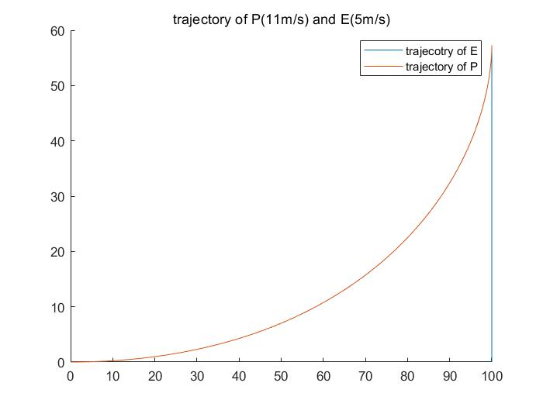

P3: trajectory of P(11m/s) and E(5m/s)

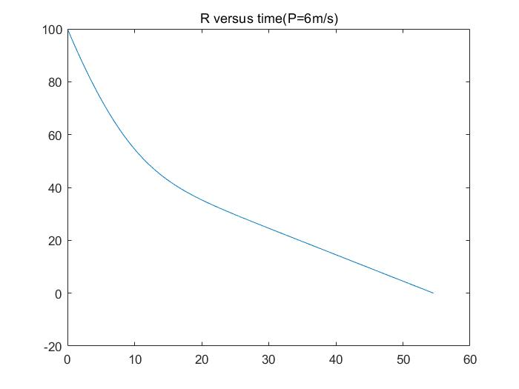

P4: R versus time(P=6m/s)

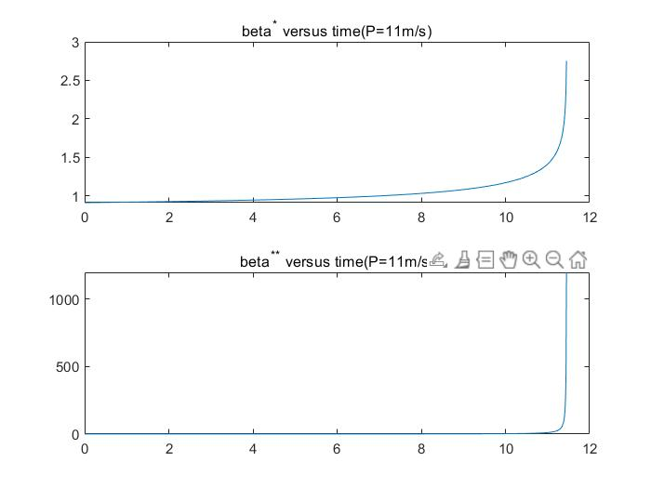

P5: $\dot{β}$  and $\ddot{β}$  versus time(P=11m/s)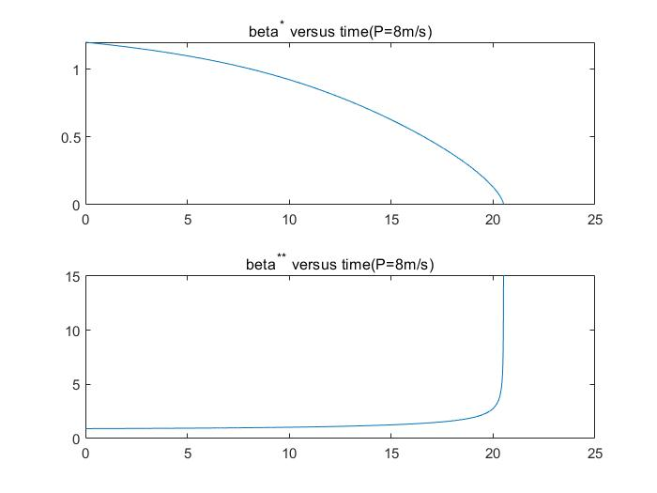

P6: $\dot{β}$  and $\ddot{β}$  versus time(P=8m/s)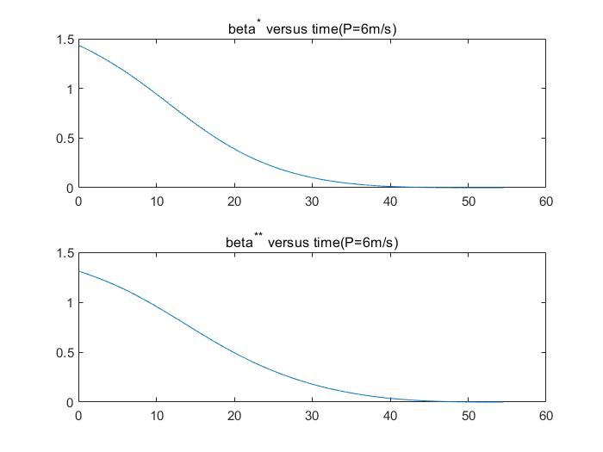

P7: $\dot{β}$  and $\ddot{β}$  versus time(P=6m/s)

For 2 we use following codes.

clc;

clear all;

VT = 5;

Vui = [6,8,11];

Vu = 6;

theta = asin(VT/Vu);

theta_E = pi/2;

time = 0:0.01:100;

finPos = 0;

opts = odeset('Events', @(t,y)StopEventPos(t,y,finPos), 'RelTol', 1e-6, 'AbsTol', 1e-6);

tspan = time;

figure(1)

R_DP_all = {};

T_DP_all = {};

R_CBP_all = {};

T_CBP_all = {};

for i=1:3

Vu = Vui(i);

theta = asin(VT/Vu);

%%

%calculate DP

odefun = @(t,y) deriv(t,y,VT,Vu,theta_E); % Anonymous derivative function with A

f0 = [100;0];

[T,R_beta] = ode45(odefun,tspan,f0,opts);

len_tra = length(T);

traj_E = zeros(len_tra,2);

traj_E(:,1) = 100*ones(len_tra,1);

traj_E(:,2) = VT*T;

R = R_beta(:,1);

beta = R_beta(:,2);

x_DP = traj_E(:,1)-R.*cos(beta);

y_DP = traj_E(:,2)-R.*sin(beta);

R_DP_all{i} = R;

T_DP_all{i} = T;

%%

%to calculate CBP

beta_CBP = 0;

ode_CBP = @(t,R) CBP(t,R,VT,Vu,theta_E,theta,beta_CBP);

R0 = 100;

[T_CBP,R_CBP] = ode45(ode_CBP,tspan,R0,opts);

len_tra_CBP = length(T_CBP);

traj_E_CBP = zeros(len_tra_CBP,2);

traj_E_CBP(:,1) = 100*ones(len_tra_CBP,1);

traj_E_CBP(:,2) = VT*T_CBP;

x_CBP = traj_E_CBP(:,1)-R_CBP.*cos(beta_CBP);

y_CBP = traj_E_CBP(:,2)-R_CBP.*sin(beta_CBP);

R_CBP_all{i} = R_CBP;

T_CBP_all{i} = T_CBP;

%%

%plot

subplot(1,3,i)

hold on

plot(traj_E(:,1),traj_E(:,2));

plot(x_DP,y_DP);

plot(x_CBP,y_CBP);

legend("trajectory-E","trajectory-DP","trajectory-CBP")

title("trajectories under Vp=",int2str(Vu))

hold off

end

figure(2)

for i=1:3

subplot(1,3,i)

hold on

plot(T_DP_all{i},R_DP_all{i});

plot(T_CBP_all{i},R_CBP_all{i});

legend("R for DP","R for CBP")

Vu = Vui(i);

title("R under Vp=",int2str(Vu))

hold off

end

%%

%functions

function dy = deriv(t,y,VT,Vu,theta_E)

%y(1) = R, y(2) = beta

R = y(1);

beta = y(2);

dR = VT*cos(beta-theta_E)-Vu;

d_beta = -VT*sin(beta-theta_E)/R;

dy = [dR;d_beta];

end

function dR = CBP(t,R,VT,Vu,theta_E,theta,beta)

%y(1) = R, y(2) = beta

dR = VT*cos(beta-theta_E)-Vu*cos(beta-theta);

end

function [value, isterminal, direction] = StopEventPos(t, y, pos)

value = y(1) - pos;

isterminal = 1; % Stop the integration

direction = 0;

end

And the pictures look like below:

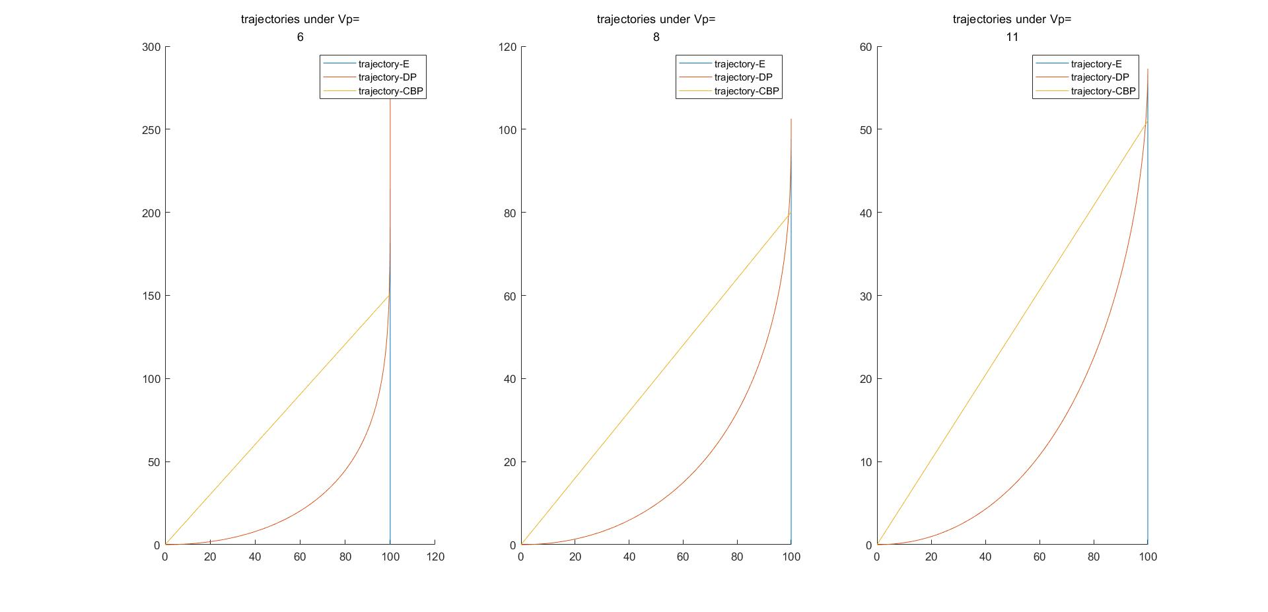

P8: trajectory of E,P with DP and CBP under Vp = [6,8,11]m/s

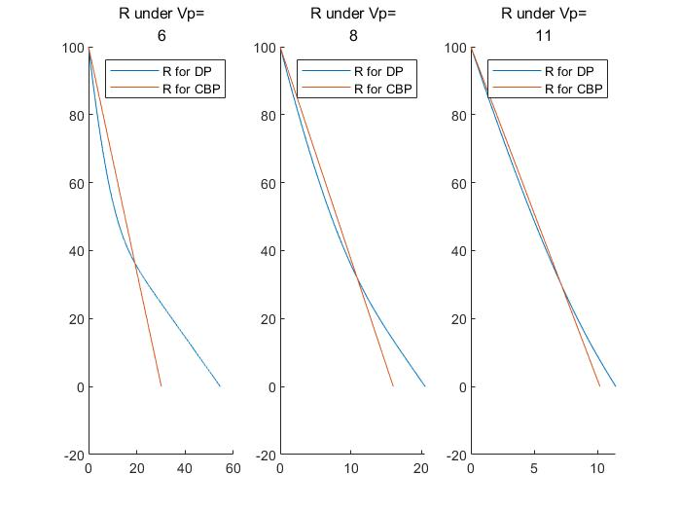

P9: R with DP and CBP under Vp = [6,8,11]m/s versus time

As Vp increases, the difference between the times of captured obtained for DP and CBP shrinks

For 3 we use following codes.

clc;

clear all;

c0 = 0;

VT = 5;

Vu = 6;

theta_E = pi/2;

time = 0:0.01:100;

tspan = time;

theta = asin(VT/Vu);

finPos = 0;

opts = odeset('Events', @(t,y)StopEventPos(t,y,finPos), 'RelTol', 1e-6, 'AbsTol', 1e-6);

lambdas_1 = [0.25, 0.5, 0.75, 0.9];

lambdas_2 = [1, 2, 5, 50];

lambdas = [0.25, 0.5, 0.75, 0.9, 1, 2, 5, 50];

xpos_PP_all = {};

ypos_PP_all = {};

x_CBP_all = {};

y_CBP_all = {};

traj_E1 = zeros(1,1);

traj_E2 = zeros(1,1);

R_PP_all = {};

R_CBP_all = {};

for i=1:length(lambdas)

lambda = lambdas(i);

%%

%to calculate PP

%beta_PP = 0;

ode_PP = @(t,y) PP(t,y,VT,Vu,theta_E,lambda);

y0 = [100;0];

[T_PP,y_PP] = ode45(ode_PP,tspan,y0,opts);

R =y_PP(:,1);

R_PP_all{i} = R;

beta = y_PP(:,2);

len_tra_PP = length(T_PP);

traj_E_PP = zeros(len_tra_PP,2);

traj_E_PP(:,1) = 100*ones(len_tra_PP,1);

traj_E_PP(:,2) = VT*T_PP;

xpos_PP = traj_E_PP(:,1)-R.*cos(beta);

ypos_PP = traj_E_PP(:,2)-R.*sin(beta);

xpos_PP_all{i}=xpos_PP;

ypos_PP_all{i}=ypos_PP;

if(i<length(lambdas_1))

if(length(traj_E_PP(:,1))>length(traj_E1(:,1)))

traj_E1 = traj_E_PP;

end

else

if(length(traj_E_PP(:,1))>length(traj_E2(:,1)))

traj_E2 = traj_E_PP;

end

end

%%

%to calculate CBP

beta_CBP = 0;

ode_CBP = @(t,R) CBP(t,R,VT,Vu,theta_E,theta,beta_CBP);

R0 = 100;

[T_CBP,R_CBP] = ode45(ode_CBP,tspan,R0,opts);

R_CBP_all{i} = R_CBP;

len_tra_CBP = length(T_CBP);

traj_E_CBP = zeros(len_tra_CBP,2);

traj_E_CBP(:,1) = 100*ones(len_tra_CBP,1);

traj_E_CBP(:,2) = VT*T_CBP;

x_CBP = traj_E_CBP(:,1)-R_CBP.*cos(beta_CBP);

y_CBP = traj_E_CBP(:,2)-R_CBP.*sin(beta_CBP);

x_CBP_all{i} = x_CBP;

y_CBP_all{i}=y_CBP;

if(i<length(lambdas_1))

if(length(traj_E_CBP(:,1))>length(traj_E1(:,1)))

traj_E1 = traj_E_CBP;

end

else

if(length(traj_E_CBP(:,1))>length(traj_E2(:,1)))

traj_E2 = traj_E_CBP;

end

end

end

%%

%PP and CBP <1

figure(1) %trajectory

hold on

for i=1:length(lambdas_1)

plot(xpos_PP_all{i},ypos_PP_all{i})

end

plot(traj_E1(:,1),traj_E1(:,2))

hold off

legend('traj \lambda=0.25','traj \lambda=0.5','traj \lambda=0.75','traj \lambda=0.9','traj of E')

title('trajectory for different P and E when \lambda<1')

figure(2) %R

hold on

for i=1:length(lambdas_1)

plot((0:1:(length(R_PP_all{i})-1))/100 , R_PP_all{i});

end

hold off

legend('R(\lambda=0.25)','R (\lambda=0.5)','R (\lambda=0.75)','R (\lambda=0.9)')

title('R versus time when \lambda<1')

%%

%PP and CBP >1

figure(3) %trajectory

hold on

len = length(lambdas_1);

for i=len+1:1:len+length(lambdas_2)

plot(xpos_PP_all{i},ypos_PP_all{i});

end

plot(x_CBP_all{i},y_CBP_all{i},'--');

plot(traj_E2(:,1),traj_E2(:,2))

legend('PP traj \lambda=1','PP traj \lambda=2',...

'PP traj \lambda=5','PP traj \lambda=50',...

'CBP traj', 'traj of E');

title('trajectory for different P and E when \lambda>1')

hold off

figure(4) %R

hold on

for i=len+1:1:len+length(lambdas_2)

plot((0:1:(length(R_PP_all{i})-1))/100 , R_PP_all{i});

end

plot((0:1:(length(R_CBP_all{i})-1))/100,R_CBP_all{i},'--');

hold off

legend('R(\lambda=1)','R (\lambda=2)','R (\lambda=5)','R (\lambda=50)','R CBP')

title('R versus time when \lambda>1')

function dR = CBP(t,R,VT,Vu,theta_E,theta,beta)

dR = VT*cos(beta-theta_E)-Vu*cos(beta-theta);

end

function dy = PP(t,y,VT,Vu,theta_E,lambda)

%y(1) = R, y(2) = beta

R = y(1);

beta = y(2);

theta = lambda*beta;

d_R = VT*cos(beta-theta_E)-Vu*cos(beta-theta);

d_beta = -(VT*sin(beta-theta_E)-Vu*sin(beta-theta))/R;

dy = [d_R;d_beta];

end

function dy = deriv(t,y,VT,Vu,theta_E)

%y(1) = R, y(2) = beta

R = y(1);

beta = y(2);

dR = VT*cos(beta-theta_E)-Vu;

d_beta = -VT*sin(beta-theta_E)/R;

dy = [dR;d_beta];

end

function [value, isterminal, direction] = StopEventPos(t, y, pos)

value = y(1) - pos;

isterminal = 1; % Stop the integration

direction = 0;

end

And the pictures look like below:

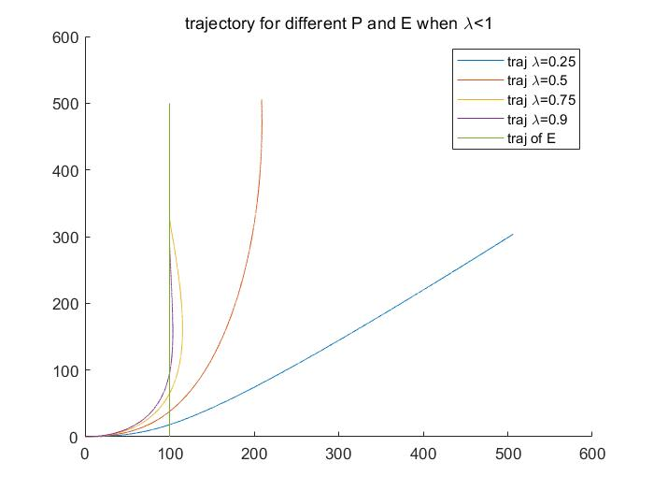

P10: trajectory for different P and E when $λ<1$

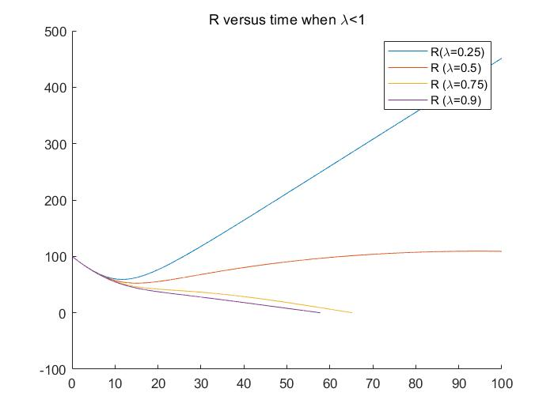

P11:R versus time when $λ<1$

Trajectory of P overshoot and as I increase $λ$, overshoot becomes small and cconverge quickly

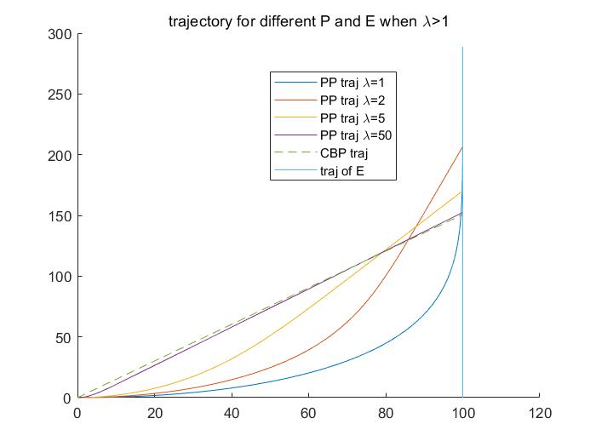

P12:trajectory of different P and E when $λ>1$

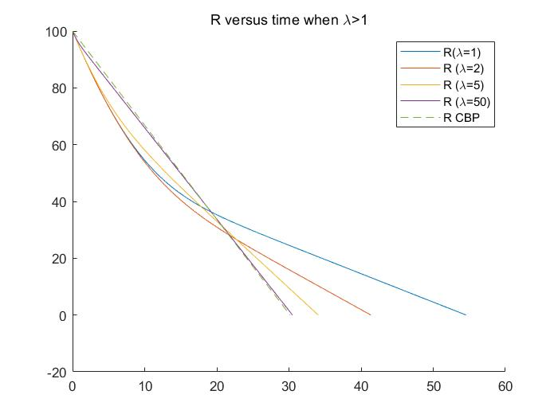

P13:R versus time when $λ>1$

As I increase $λ$, the trajectory of PP and R of PP go close to what happens in CBP. P converge quickly to E and R drop quickly as well

For 4 we use following codes.

clc;

clear all;

VT = 5;

Vu = 6;

theta_E = pi/2;

time = 0:0.01:100;

finPos = 5;

opts = odeset('Events', @(t,y)StopEventPos(t,y,finPos), 'RelTol', 1e-6, 'AbsTol', 1e-6);

odeDP = @(t,y) DP_noise(t,y,VT,Vu,theta_E); % Anonymous derivative function with A

tspan = time;

f0 = [100;0];

[T,R_beta] = ode45(odeDP,tspan,f0,opts); % Pass in column vector initial value

len_tra = length(T);

traj_E = zeros(len_tra,2);

traj_E(:,1) = 100*ones(len_tra,1);

traj_E(:,2) = VT*T;

R_DP =R_beta(:,1);

beta_DP = R_beta(:,2);

x = traj_E(:,1)-R_DP.*cos(beta_DP);

y = traj_E(:,2)-R_DP.*sin(beta_DP);

lams = [1.5,2,2.5];

xpos_PP_all = {};

ypos_PP_all = {};

R_PP_all = {};

for i=1:1:length(lams)

lambda = lams(i);

ode_PP = @(t,y) PP_noise(t,y,VT,Vu,theta_E,lambda);

y0 = [100;0];

[T_PP,y_PP] = ode45(ode_PP,tspan,y0,opts);

R_PP =y_PP(:,1);

R_PP_all{i} = R_PP;

beta_PP = y_PP(:,2);

len_tra_PP = length(T_PP);

traj_E_PP = zeros(len_tra_PP,2);

traj_E_PP(:,1) = 100*ones(len_tra_PP,1);

traj_E_PP(:,2) = VT*T_PP;

if(len_tra_PP>length(traj_E))

traj_E = traj_E_PP;

end

xpos_PP = traj_E_PP(:,1)-R_PP.*cos(beta_PP);

ypos_PP = traj_E_PP(:,2)-R_PP.*sin(beta_PP);

xpos_PP_all{i} = xpos_PP;

ypos_PP_all{i} = ypos_PP;

end

figure(1)

hold on

plot(traj_E(:,1),traj_E(:,2));

plot(x,y);

for i=1:length(xpos_PP_all)

x_pp = xpos_PP_all{i};

y_pp = ypos_PP_all{i};

plot(x_pp,y_pp);

end

legend('traj of E','traj of DP', 'traj of PP(\lambda=1.5)', 'traj of PP(\lambda=2)', 'traj of PP(\lambda=2.5)');

title("trajectory of E and P")

figure(2)

hold on

plot((0:1:length(R_DP)-1)/100, R_DP);

for i=1:length(R_PP_all)

plot((0:1:length(R_PP_all{i})-1)/100,R_PP_all{i});

end

legend('R(DP)','R(\lambda=1.5)','R (\lambda=2)','R (\lambda=2.5)')

hold off

title("R versus time")

function dy = PP(t,y,VT,Vu,theta_E,lambda)

%y(1) = R, y(2) = beta

R = y(1);

beta = y(2);

theta = lambda*beta;

d_R = VT*cos(beta-theta_E)-Vu*cos(beta-theta);

d_beta = -(VT*sin(beta-theta_E)-Vu*sin(beta-theta))/R;

dy = [d_R;d_beta];

end

function dy = PP_noise(t,y,VT,Vu,theta_E,lambda)

%y(1) = R, y(2) = beta

R = y(1);

beta = y(2);

theta = lambda*(beta+0.25*randn);

d_R = VT*cos(beta-theta_E)-Vu*cos(beta-theta);

d_beta = -(VT*sin(beta-theta_E)-Vu*sin(beta-theta))/R;

dy = [d_R;d_beta];

end

function dy = DP_noise(t,y,VT,Vu,theta_E)

%direct DP

%y(1) = R, y(2) = beta

R = y(1);

beta = y(2);

theta = beta+0.25*randn;

dR = VT*cos(beta-theta_E)-Vu*cos(beta-theta);

d_beta = -(VT*sin(beta-theta_E)-Vu*sin(beta-theta))/R;

dy = [dR;d_beta];

end

function [value, isterminal, direction] = StopEventPos(t, y, pos)

value = y(1) - pos;

isterminal = 1; % Stop the integration

direction = 0;

end

And the pictures look like below:

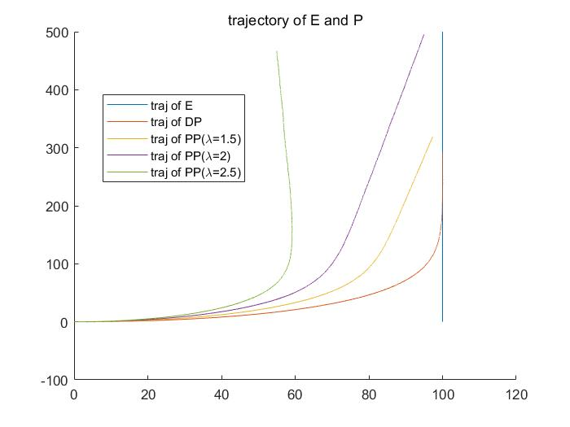

P14: trajectory of E and P with noise

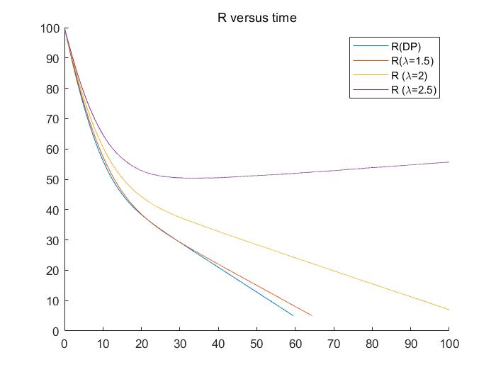

P15: R versus time with noise

As I increase $λ$, the trajectory of P deviate away and converge slowly, even diverge. And R decrease slowly, even increase. The reason is that the increase of $λ$ mmultipliesthe noise on our control angle $θ_{p}$, and it gives a huge error.

For 5 we use following codes.

clc;

clear all;

c0 = 0;

VT = 5;

Vu = 6;

theta_E = pi/2;

time = 0:0.01:100;

tspan = time;

theta = asin(VT/Vu);

finPos = 0;

opts = odeset('Events', @(t,y)StopEventPos(t,y,finPos), 'RelTol', 1e-6, 'AbsTol', 1e-6);

lambdas_1 = [0.25, 0.5, 0.75, 0.9];

lambdas_2 = [1, 2, 5, 50];

lambdas = [0.25, 0.5, 0.75, 0.9, 1, 2, 5, 50];

xpos_PP_all = {};

ypos_PP_all = {};

R_PP_all = {};

x_CBP_all = {};

y_CBP_all = {};

traj_E1 = zeros(1,1);

traj_E2 = zeros(1,1);

R_CBP_all = {};

for i=1:length(lambdas)

lambda = lambdas(i);

%%

%to calculate PP

%beta_PP = 0;

ode_PP = @(t,y) PP(t,y,VT,Vu,theta_E,lambda);

y0 = [100;0];

[T_PP,y_PP] = ode45(ode_PP,tspan,y0,opts);

R =y_PP(:,1);

R_PP_all{i} = R;

beta = y_PP(:,2);

len_tra_PP = length(T_PP);

ode_traj = @(t,s) cal_traj_E(t,s,VT,theta_E);

[T_traj_E,traj_E] = ode45(ode_traj, T_PP, y0,opts);

%theta_tao = cos(T_PP)+pi/2;

%traj_E = zeros(len_tra_PP,2);

%traj_E(:,1) = 100*ones(len_tra_PP,1);

%traj_E(:,2) = VT*T_PP;

xpos_PP = traj_E(:,1)-R.*cos(beta);

ypos_PP = traj_E(:,2)-R.*sin(beta);

xpos_PP_all{i}=xpos_PP;

ypos_PP_all{i}=ypos_PP;

if(i<length(lambdas_1))

if(length(traj_E(:,1))>length(traj_E1(:,1)))

traj_E1 = traj_E;

end

else

if(length(traj_E(:,1))>length(traj_E2(:,1)))

traj_E2 = traj_E;

end

end

%%

%to calculate CBP

beta_CBP = 0;

ode_CBP = @(t,R) CBP(t,R,VT,Vu,theta_E,theta,beta_CBP);

R0 = 100;

[T_CBP,R_CBP] = ode45(ode_CBP,tspan,R0,opts);

R_CBP_all{i} = R_CBP;

len_tra_CBP = length(T_CBP);

[T_traj_E_CBP,traj_E_CBP] = ode45(ode_traj, T_CBP, y0,opts);

%traj_E_CBP = zeros(len_tra_CBP,2);

%traj_E_CBP(:,1) = 100*ones(len_tra_CBP,1);

%traj_E_CBP(:,2) = VT*T_CBP;

x_CBP = traj_E_CBP(:,1)-R_CBP.*cos(beta_CBP);

y_CBP = traj_E_CBP(:,2)-R_CBP.*sin(beta_CBP);

x_CBP_all{i} = x_CBP;

y_CBP_all{i}=y_CBP;

if(i<length(lambdas_1))

if(length(traj_E_CBP(:,1))>length(traj_E1(:,1)))

traj_E1 = traj_E_CBP;

end

else

if(length(traj_E_CBP(:,1))>length(traj_E2(:,1)))

traj_E2 = traj_E_CBP;

end

end

end

%%

%PP and CBP <1

figure(1) %trajectory

hold on

for i=1:length(lambdas_1)

plot(xpos_PP_all{i},ypos_PP_all{i})

end

plot(traj_E1(:,1),traj_E1(:,2))

hold off

legend('traj \lambda=0.25','traj \lambda=0.5','traj \lambda=0.75','traj \lambda=0.9','traj of E')

title('trajectory for different P and E when \lambda<1')

figure(2) %R

hold on

for i=1:length(lambdas_1)

plot((0:1:(length(R_PP_all{i})-1))/100 , R_PP_all{i});

end

hold off

legend('R(\lambda=0.25)','R (\lambda=0.5)','R (\lambda=0.75)','R (\lambda=0.9)')

title('R versus time when \lambda<1')

%%

%PP and CBP >1

figure(3) %trajectory

hold on

len = length(lambdas_1);

for i=len+1:1:len+length(lambdas_2)

plot(xpos_PP_all{i},ypos_PP_all{i});

end

plot(x_CBP_all{i},y_CBP_all{i},'--');

plot(traj_E2(:,1),traj_E2(:,2))

legend('PP traj \lambda=1','PP traj \lambda=2',...

'PP traj \lambda=5','PP traj \lambda=50',...

'CBP traj', 'traj of E');

title('trajectory for different P and E when \lambda>1')

hold off

figure(4) %R

hold on

for i=len+1:1:len+length(lambdas_2)

plot((0:1:(length(R_PP_all{i})-1))/100 , R_PP_all{i});

end

plot((0:1:(length(R_CBP_all{i})-1))/100,R_CBP_all{i},'--');

hold off

legend('R(\lambda=1)','R (\lambda=2)','R (\lambda=5)','R (\lambda=50)','R CBP')

title('R versus time when \lambda>1')

function ds = cal_traj_E(t,s,VT,theta_E)

dx = VT*cos(theta_E+cos(t));

dy = VT*sin(theta_E+cos(t));

ds = [dx;dy];

end

function dR = CBP(t,R,VT,Vu,theta_E,theta,beta)

dR = VT*cos(beta-theta_E-cos(t))-Vu*cos(beta-theta);

end

function dy = PP(t,y,VT,Vu,theta_E,lambda)

%y(1) = R, y(2) = beta

R = y(1);

beta = y(2);

theta = lambda*beta;

d_R = VT*cos(beta-theta_E-cos(t))-Vu*cos(beta-theta);

d_beta = -(VT*sin(beta-theta_E-cos(t))-Vu*sin(beta-theta))/R;

dy = [d_R;d_beta];

end

function dy = deriv(t,y,VT,Vu,theta_E)

%y(1) = R, y(2) = beta

R = y(1);

beta = y(2);

dR = VT*cos(beta-theta_E-cos(t))-Vu;

d_beta = -VT*sin(beta-theta_E-cos(t))/R;

dy = [dR;d_beta];

end

function [value, isterminal, direction] = StopEventPos(t, y, pos)

value = y(1) - pos;

isterminal = 1; % Stop the integration

direction = 0;

end

And the pictures look like below:

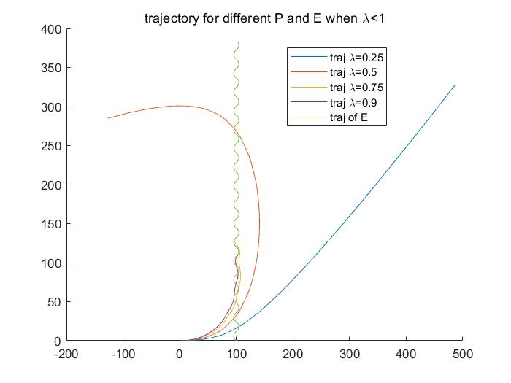

P16: trajectory for different P and E when $λ<1$

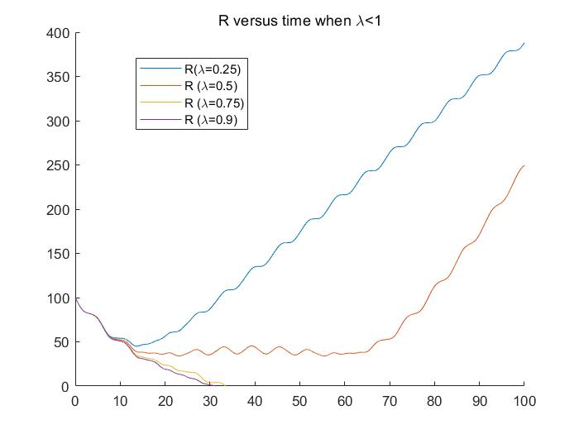

P17: R versus time when $λ<1$

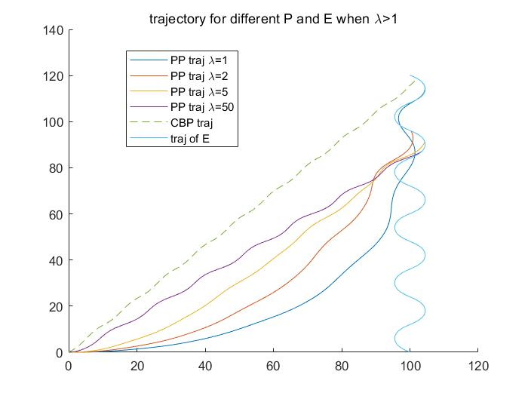

P18: trajectory for different P and E when $λ>1$

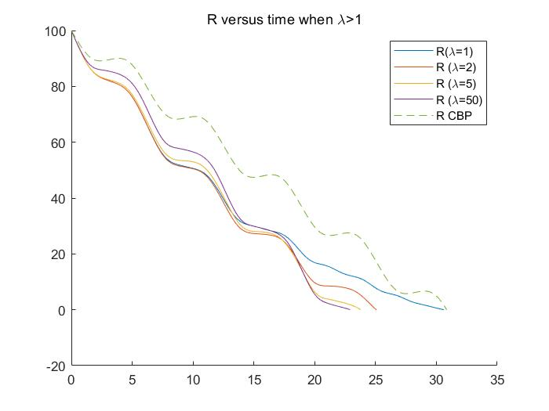

P19: R versus time when $λ>1$

It is quite different from what in Problem3. If $λ>1$, almost all PP behave better than CBP and when increase $λ$, PP will get away rather than converge to the trajectory of CBP. And if $λ$ is too small, it will get a larger overshoot.

For 6 we use following codes.

clc;

clear all;

VT = 5;

Vu = 6;

theta_E = pi/2;

time = 0:0.01:100;

finPos = 0.5;

opts = odeset('Events', @(t,y)StopEventPos(t,y,finPos), 'RelTol', 1e-6, 'AbsTol', 1e-6);

odeDP = @(t,y) DP_noise(t,y,VT,Vu,theta_E); % Anonymous derivative function with A

tspan = time;

f0 = [100;0];

[T,R_beta] = ode45(odeDP,tspan,f0,opts); % Pass in column vector initial value

ode_traj = @(t,s) cal_traj_E(t,s,VT,theta_E);

[T_traj_E,traj_E] = ode45(ode_traj, T, f0,opts);

len_tra = length(T);

R_DP =R_beta(:,1);

beta_DP = R_beta(:,2);

x = traj_E(:,1)-R_DP.*cos(beta_DP);

y = traj_E(:,2)-R_DP.*sin(beta_DP);

lams = [1.5,2,2.5];

xpos_PP_all = {};

ypos_PP_all = {};

R_PP_all = {};

for i=1:1:length(lams)

lambda = lams(i);

ode_PP = @(t,y) PP_noise(t,y,VT,Vu,theta_E,lambda);

y0 = [100;0];

[T_PP,y_PP] = ode45(ode_PP,tspan,y0,opts);

ode_traj = @(t,s) cal_traj_E(t,s,VT,theta_E);

[T_traj_E,traj_E_PP] = ode45(ode_traj, T_PP, y0,opts);

if(length(traj_E_PP)>length(traj_E))

traj_E = traj_E_PP;

end

R_PP =y_PP(:,1);

R_PP_all{i} = R_PP;

beta_PP = y_PP(:,2);

len_tra_PP = length(T_PP);

%traj_E_PP = zeros(len_tra_PP,2);

%traj_E_PP(:,1) = 100*ones(len_tra_PP,1);

%traj_E_PP(:,2) = VT*T_PP;

xpos_PP = traj_E_PP(:,1)-R_PP.*cos(beta_PP);

ypos_PP = traj_E_PP(:,2)-R_PP.*sin(beta_PP);

xpos_PP_all{i} = xpos_PP;

ypos_PP_all{i} = ypos_PP;

end

figure(1)

hold on

plot(traj_E(:,1),traj_E(:,2));

plot(x,y);

for i=1:length(xpos_PP_all)

x_pp = xpos_PP_all{i};

y_pp = ypos_PP_all{i};

plot(x_pp,y_pp);

end

legend('traj of E','traj of DP', 'traj of PP(\lambda=1.5)', 'traj of PP(\lambda=2)', 'traj of PP(\lambda=2.5)');

title("trajectory of E and P")

figure(2)

hold on

plot((0:1:length(R_DP)-1)/100, R_DP);

for i=1:length(R_PP_all)

plot((0:1:length(R_PP_all{i})-1)/100,R_PP_all{i});

end

legend('R(DP)','R(\lambda=1.5)','R (\lambda=2)','R (\lambda=2.5)')

hold off

title("R versus time")

function dy = PP_noise(t,y,VT,Vu,theta_E,lambda)

%y(1) = R, y(2) = beta

R = y(1);

beta = y(2);

theta = lambda*(beta+0.25*randn);

d_R = VT*cos(beta-theta_E-cos(t))-Vu*cos(beta-theta);

d_beta = -(VT*sin(beta-theta_E-cos(t))-Vu*sin(beta-theta))/R;

dy = [d_R;d_beta];

end

function dy = DP_noise(t,y,VT,Vu,theta_E)

%direct DP

%y(1) = R, y(2) = beta

R = y(1);

beta = y(2);

theta = beta+0.25*randn;

dR = VT*cos(beta-theta_E-cos(t))-Vu*cos(beta-theta);

d_beta = -(VT*sin(beta-theta_E-cos(t))-Vu*sin(beta-theta))/R;

dy = [dR;d_beta];

end

function ds = cal_traj_E(t,s,VT,theta_E)

dx = VT*cos(theta_E+cos(t));

dy = VT*sin(theta_E+cos(t));

ds = [dx;dy];

end

function [value, isterminal, direction] = StopEventPos(t, y, pos)

value = y(1) - pos;

isterminal = 1; % Stop the integration

direction = 0;

end

And the picture look like below:

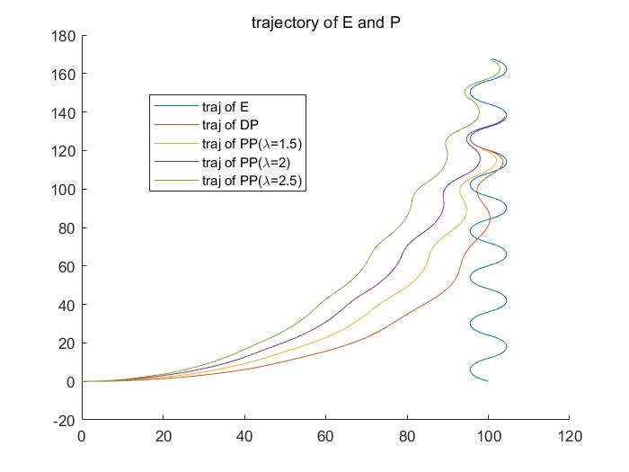

P20: trajectory of E and P

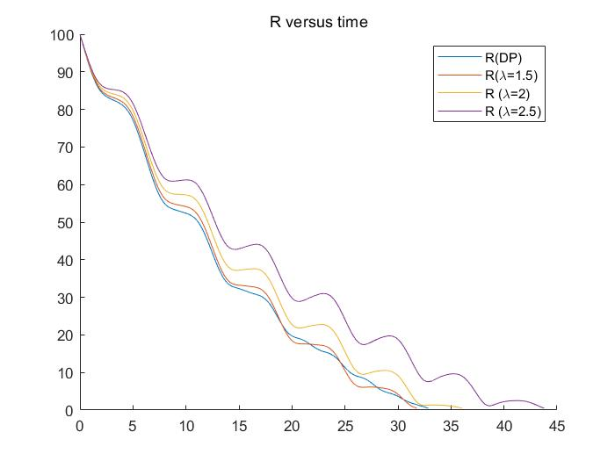

P21: R versus time

It is different from problem4 because all trajectory converge

For 7a we use following codes.

clc;

clear all;

Lams = [3,4,5];

t = 0:0.001:9.999;

tf_star = 10;

T = 0.001;

opts = odeset( 'RelTol', 1e-6, 'AbsTol', 1e-6);

figure(1)

hold on

for i=1:length(Lams)

lam = Lams(i);

ode_p = @(t,p) deriv_p(t,p,lam,tf_star,T);

tp = 9.999-t;

p0 = [1;0];

[T_P,p] = ode45(ode_p,tp,p0,opts);

p_tao = flip(p); %from zeros to tf*

tao = flip(T_P); %from zeros to tf*

G_tf_tao = lam*p_tao(:,2)./(T*(tf_star-tao));

TG_minus = -T*G_tf_tao; %from zeros to tf*

%flip(TG_minus);

x_axis = (tf_star-tao)/T;

plot(x_axis(1:end-1),TG_minus(1:end-1));

end

hold off

legend('\Lambda=3','\Lambda=4','\Lambda=5');

xlim([0,10]);

title('-TG(t_f,t) versus (t_f-t)/T')

function dp = deriv_p(t,p,lam,tf_star,T)

p1 = p(1);

p2 = p(2);

dp1 = lam/(T*(tf_star-t))*p2;

dp2 = -p1+p2/T;

dp = [dp1;dp2];

end

And the picture look like below:

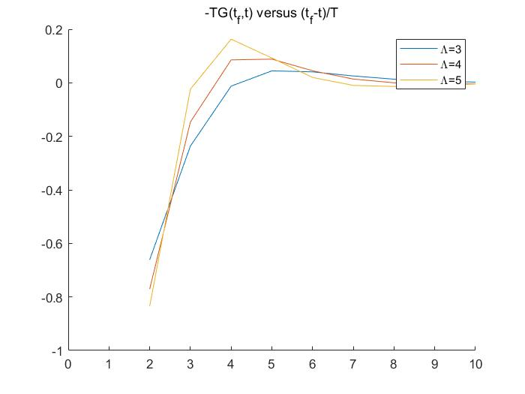

P22: $-TG\left(t_{f},t\right) versus \frac{t_{f}-t}{T}$

7b:

Interpret 7a: if evader manuvers at the very close time when the pursuer catch it, basically very close to 0 of X-axis in P22(very little of time-to-go), then the miss distance will be very large. After that, as time-to-go goes larger, the miss distance will decrease to 0, then overshoot a little bit. Finally, it goes to 0 gradually.

Picture(a): Evader maneuvers at 0 and only maneuvers once. The normalized time-to-go time is (0.5-0)/0.001 = 500. So from P22 we can know that for all $Λ$ the miss distance is moderately small. And The larger the $Λ$, the smaller the distance. Because that’s what shown in P22

Picture(c): Almost the same as A except that evader maneuvers at normalized time-to-go 1/0.001 = 1000. So the miss distance is smaller.

Picture(e): The same, miss distance is even smaller.

Picture(b): The final maneuver is almost at 0.4, normalized time-to-go 0.1/0.001=100. Then get a larger miss distance than (a)

Picture(d):The final maneuver is almost 0.8 to 0.9, normalized time-to-go is larger, get a less miss distance than (b).

Picture(f):The final maneuver is almost 4.5~4.6, normalized time-to-go is the largest, get the least distance.